**A simple model to get started**

I take notes from the code released by the Priesemann group as [a Github project](https://github.com/Priesemann-Group/covid19_inference_forecast).

There, we can have the repository of the entire work:

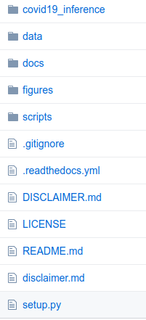

It can be used by anyone following 3 alternative ways:

1/ “Clone the repository”

Go to the Github repository of the project and click on:



2/ “Install the module via pip” (e.g. in your laptop by using the terminal)



3/ “Run the notebooks directly in Google Colab”

How to copy and edit the module? Via the files of the repository?

We can start with one folder which contains a notebook and the data files.

1. Fitting with the SIR model

The notebook file “[example_script_covid19_inference.ipynb](https://github.com/Priesemann-Group/covid19_inference_forecast/blob/master/scripts/example_script_covid19_inference.ipynb) creates the SIR model with 3 changing points from the set of parameters {λi, ti, μ, D, σ,I0}, (i = 1,2,3).

“The layout and design of the plots has been simplified in order to make the code more readable and more easily adaptable to other problems.”

Structure of the file:

0/ Install the module (like the instruction above)

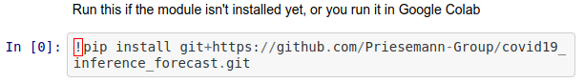

00/

The example code imports the folder “[covid19_inference](https://github.com/Priesemann-Group/covid19_inference_forecast/tree/master/covid19_inference)” which contains

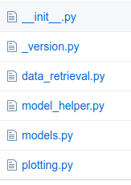

1/ Fit model

It estimates the set of parameters {λi, tj, μ, D, σ,I0}, (i = 0 to 3; j = 0 to 2) plus the durations over which the changes (labeled by j) are taking place, called transients at tj by using: a/ prior knowledge on tj,

1.1/ Parameters:

* **new_cases_obs** ([*list*](https://docs.python.org/3/library/stdtypes.html#list) *or array*) – Timeseries (day over day) of newly reported cases (not the total number)
* **change_points_list** (*list of dicts*) –  
   List of dictionaries, each corresponding to one change point.  
    
   Each dict can have the following key-value pairs. If a pair is not provided, the respective default is used.  
  + pr_mean_date_begin_transient : datetime.datetime, NO default
  + pr_median_lambda : number, same as default priors, below
  + pr_sigma_lambda : number, same as default priors, below
  + pr_sigma_date_begin_transient : number, 3
  + pr_median_transient_len : number, 3
  + pr_sigma_transient_len : number, 0.3
* **date_begin_simulation** ([*datetime.datetime*](https://docs.python.org/3/library/datetime.html#datetime.datetime)) – The begin of the simulation data
* **num_days_sim** (*integer*) – Number of days to forecast into the future
* **diff_data_sim** (*integer*) – Number of days that the simulation-begin predates the first data point in new_cases_obs. This is necessary so the model can fit the reporting delay. Set this parameter to a value larger than what you expect to find for the reporting delay.
* **N** (*number*) – The population size. For Germany, we used 83e6
* **priors_dict** ([*dict*](https://docs.python.org/3/library/stdtypes.html#dict)) –  
   Dictionary of the prior assumptions  
    
   Possible key-value pairs (and default values) are:
  + pr_beta_I_begin : number, default = 100
  + pr_median_lambda_0 : number, default = 0.4
  + pr_sigma_lambda_0 : number, default = 0.5
  + pr_median_mu : number, default = 1/8
  + pr_sigma_mu : number, default = 0.2
  + pr_median_delay : number, default = 8
  + pr_sigma_delay : number, default = 0.2
  + pr_beta_sigma_obs : number, default = 10
  + week_end_days : tuple, default = (6,7)
  + pr_mean_weekend_factor : number, default = 0.7
  + pr_sigma_weekend_factor :number, default = 0.17
* **weekends_modulated** ([*bool*](https://docs.python.org/3/library/functions.html#bool)) – Whether to add the prior that cases are less reported on week ends. Multiplies the new cases numbers on weekends by a number between 0 and 1, given by a prior beta distribution. The beta distribution is parametrised by pr_mean_weekend_factor and pr_sigma_weekend_factor
* **weekend_modulation_type** (*'step' or 'abs_sine':*) – whether the weekends are modulated by a step function, which only multiplies the days given by week_end_days by the week_end_factor, or whether the whole week is modulated by an abs(sin(x)) function, with an offset with flat prior.

1.2/ Returns

2/ Plot

1. Another SIR model with change points

The notebook file “SIR_with_delay_Germany_3scenarios.ipynb”

General structure of a code:

Import

(try sometimes?)

Stats

Beta, mean, sigma,

Python: object, dict, list, …,

user-defined function

def _SIR_model(

S_begin, I_begin

pm.Model() [import pymc3 as pm]

I_begin = pm.HalfCauchy(

pm.Lognormal(